**ReadMe**

Important: Please import the project to eclipse (Java EE edition) and choose “run on server” and view it in the chrome so that the site will show correctly. Thanks for your review!

**Index page function introduction:**

1. You can search for the medicine you want using the search box with auto complete function.
2. You can click the sign in button to sign in or register an account.
3. You can click each of the four categories and show the subcategories.
4. The Home button, Shop Products button, My Shopping Cart button, buttons on the banner and subcategory image will lead to the corresponding pages.

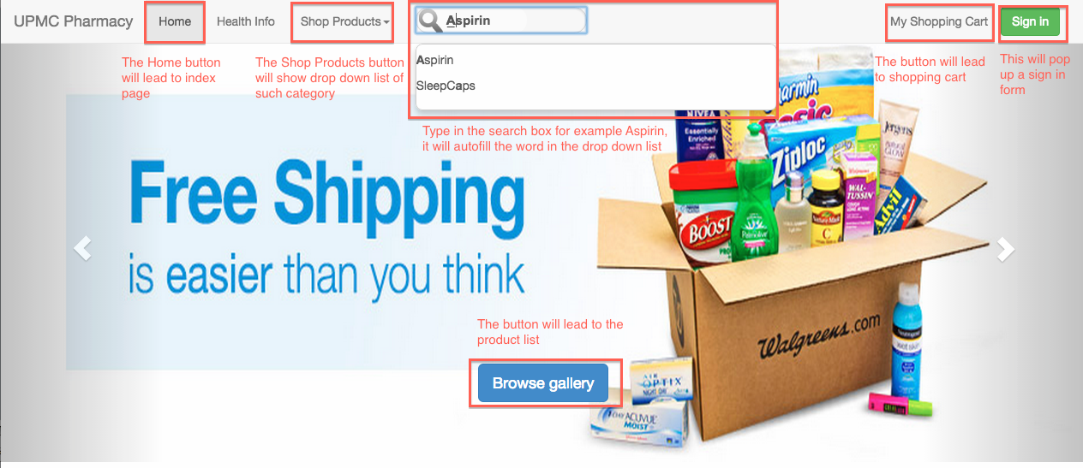

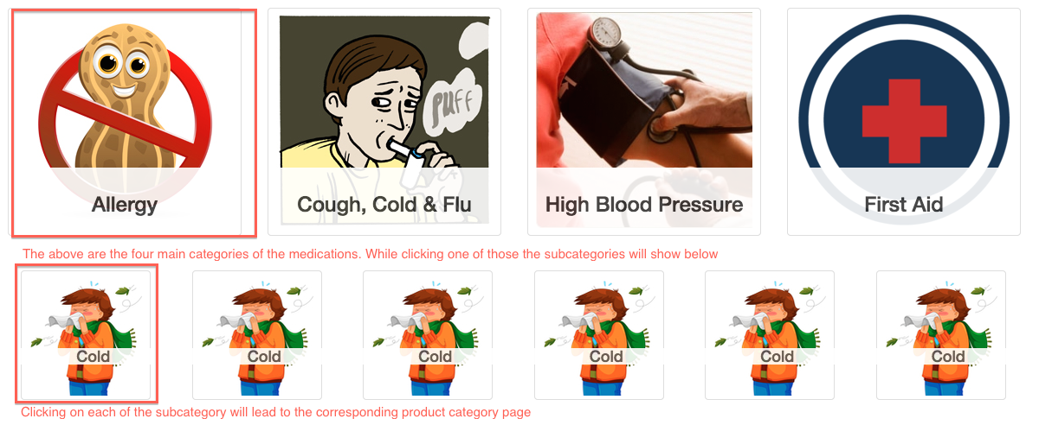

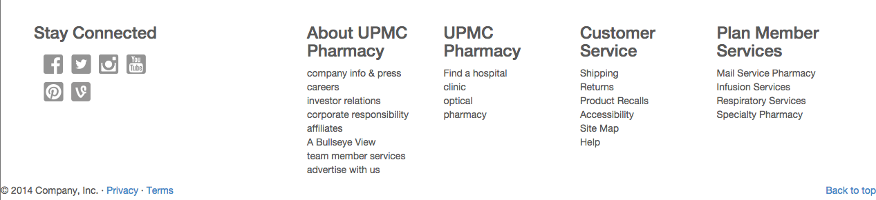

**Sign in form function introduction:**

1. It will check if the entered information is valid, otherwise an error message will show below.

2. The sign up button will only be clickable after all the information has been entered valid.

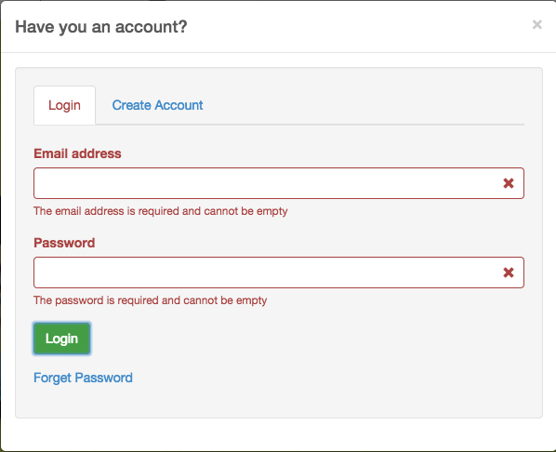

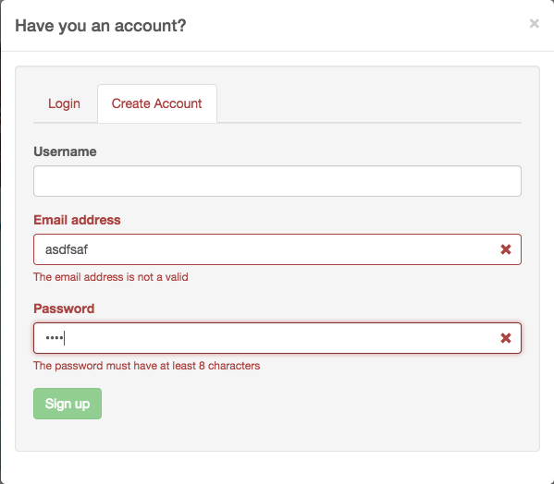

**Search Results Page & Product List Page**

When using search bar, the user will be guide to Search Results Page that shows his/her search results.

Features: Concise view contains all important information.

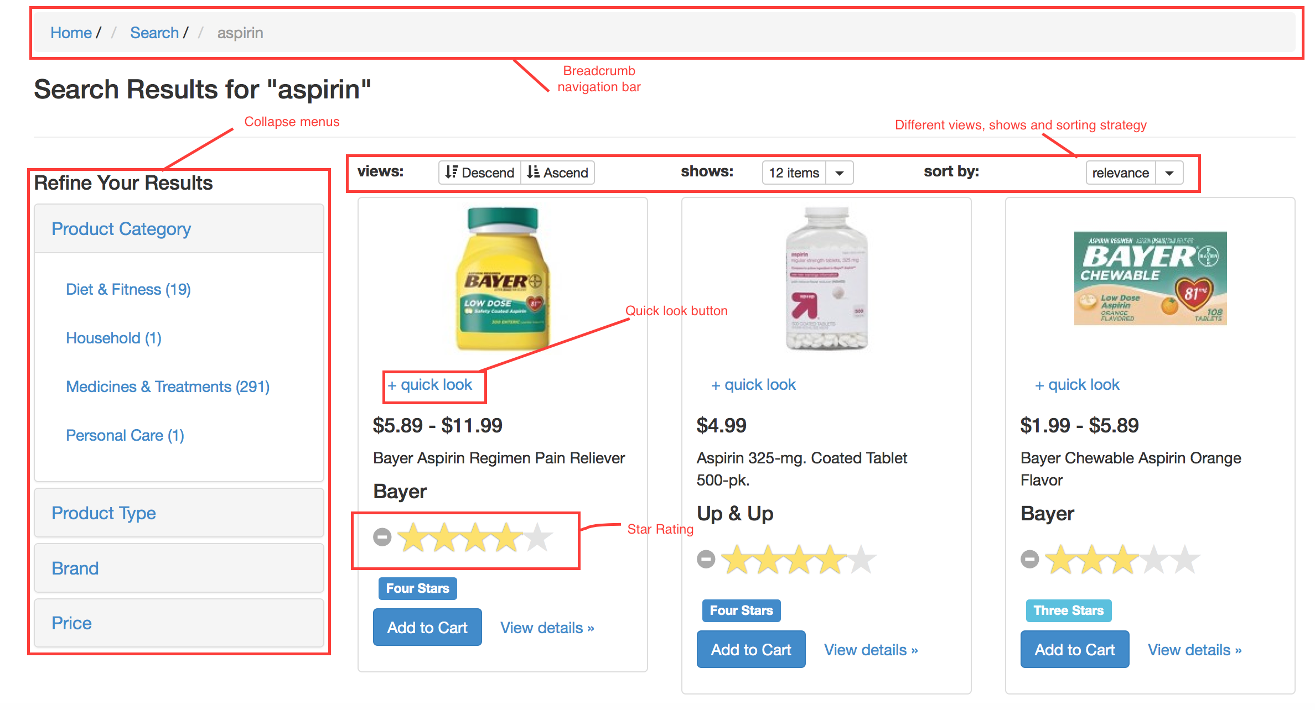

1. Breadcrumb navigation bar that helps user jump between pages quickly.

2. Different views, shows and sorting strategy.

3. Collapse menus are used to help user refine the results.

4. Star-ratings are made big and easy to see.

5. Quick look button make it much easier and quicker to view the interested product.

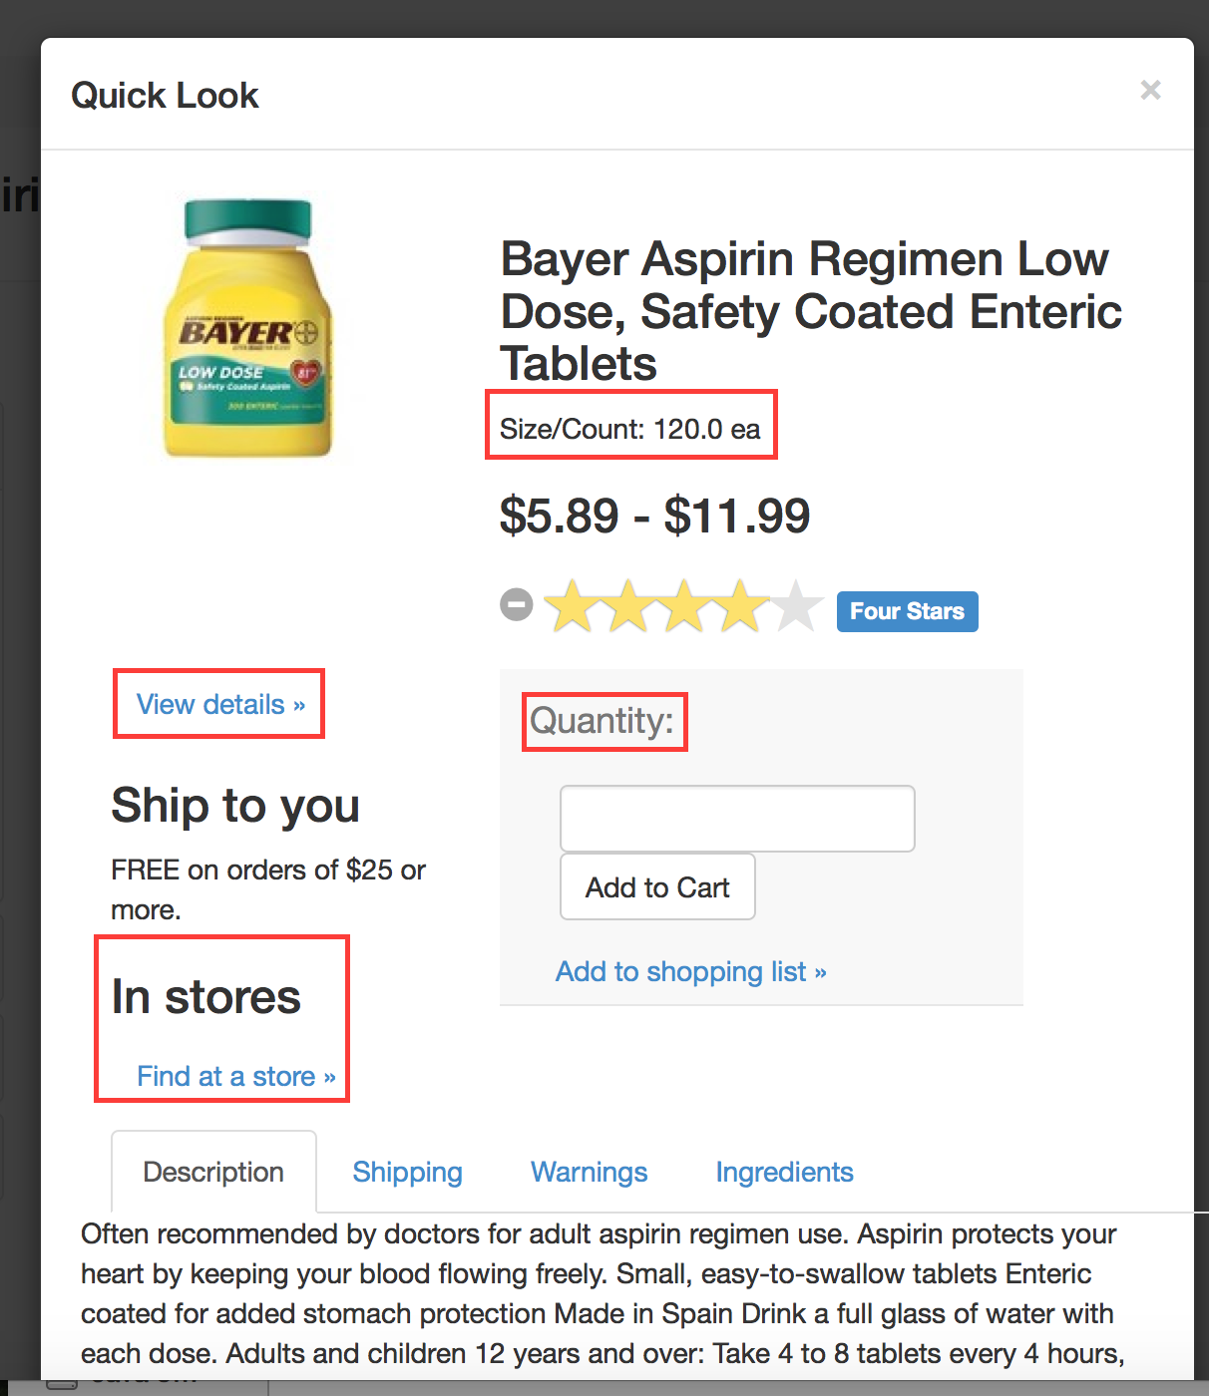

1. The quick look contains critical product information and quick access to shopping cart, user can also to go detailed information if they are interested.
2. If users are not satisfied with the results anyway there are some related products listed below.
3. The products list is almost the same.

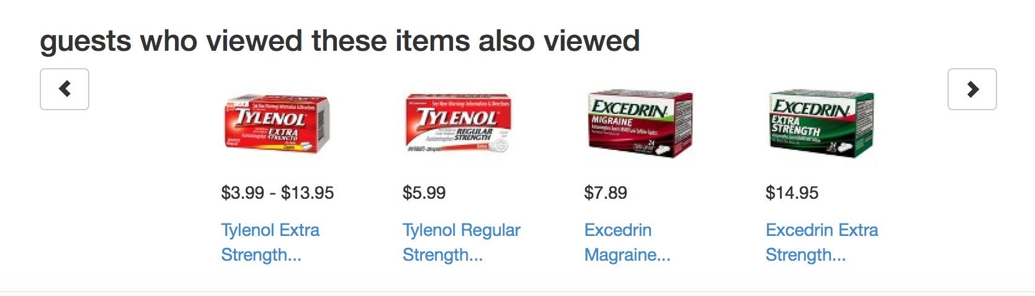

**Product detail page**

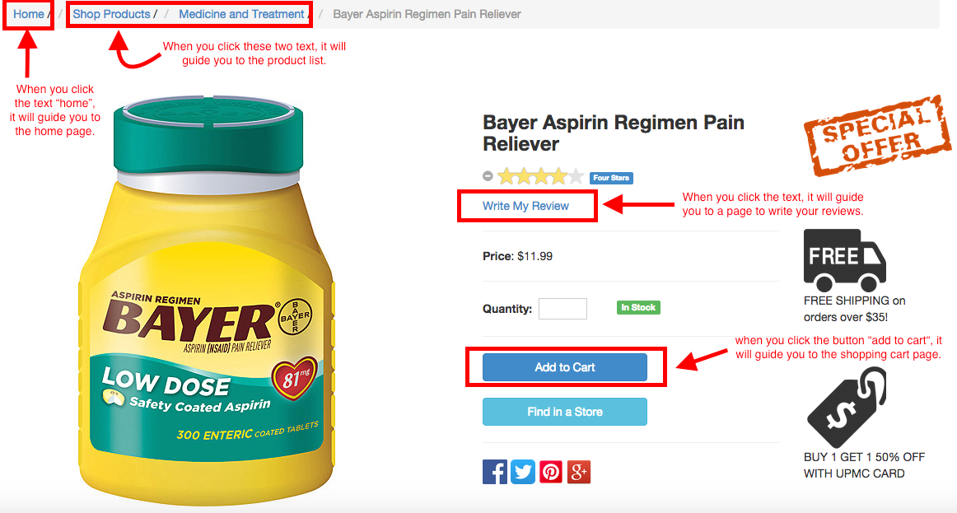

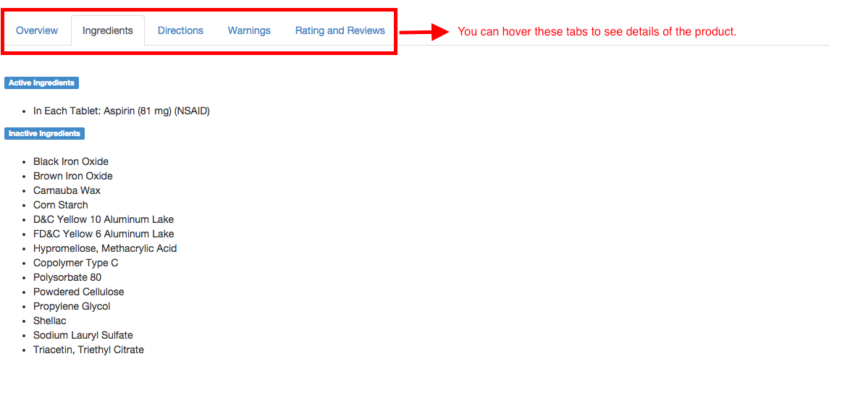

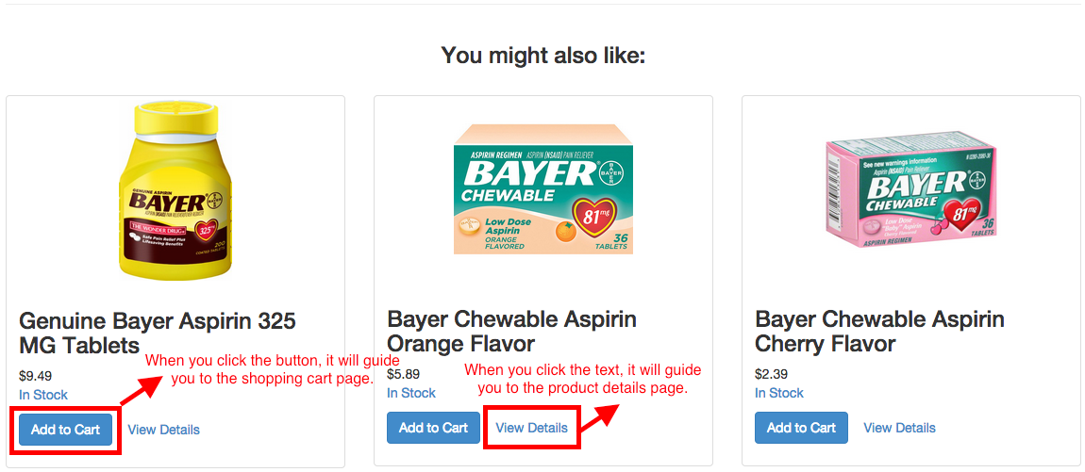

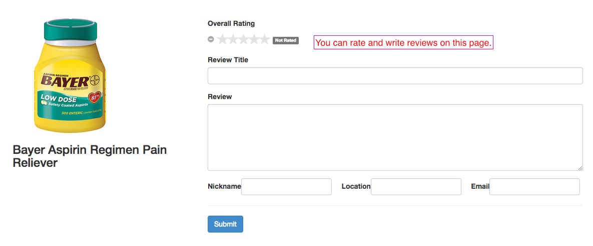

**Shopping Cart Page:**

1. General Information: (page as showed below)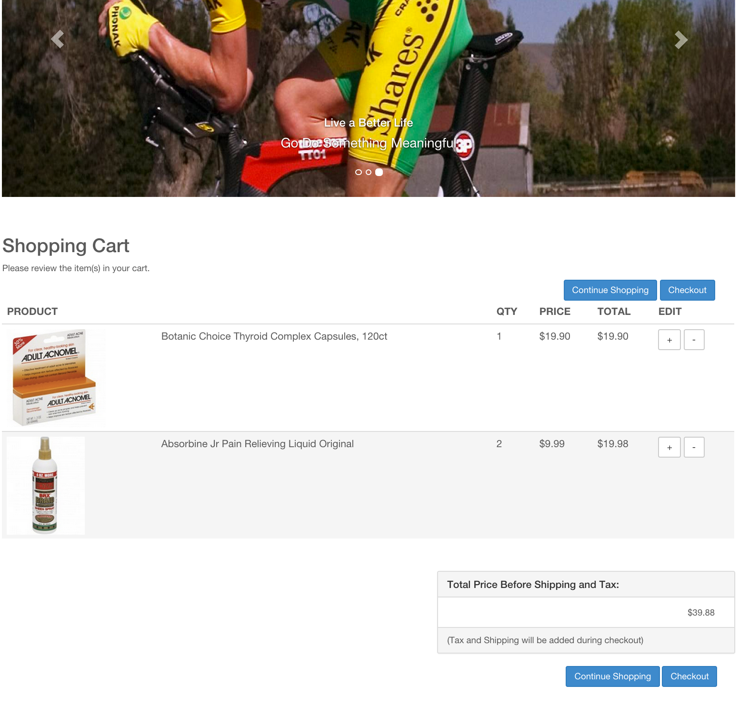
2. In the default shopping cart page, the user should be able to see a clear description of the items has been put into the cart. There will a picture associated with each item and quantity as well. In the EDIT column, user has the ability to increase or decrease the quantity of the each item in the cart (will be discussed in detail below). Since this is only a demo page, some times the increase or decrease button will not work.
3. As the user might observed, there are in total of 4 blue buttons on the page. One set of “Continue Shopping” and “Checkout” buttons above the product description and one same set below the total price. The function of each button will be described below.
4. There is a total price section right below the product description section. This section summarize the price for each item in the shopping cart and indicate the total price of this potential order to users.

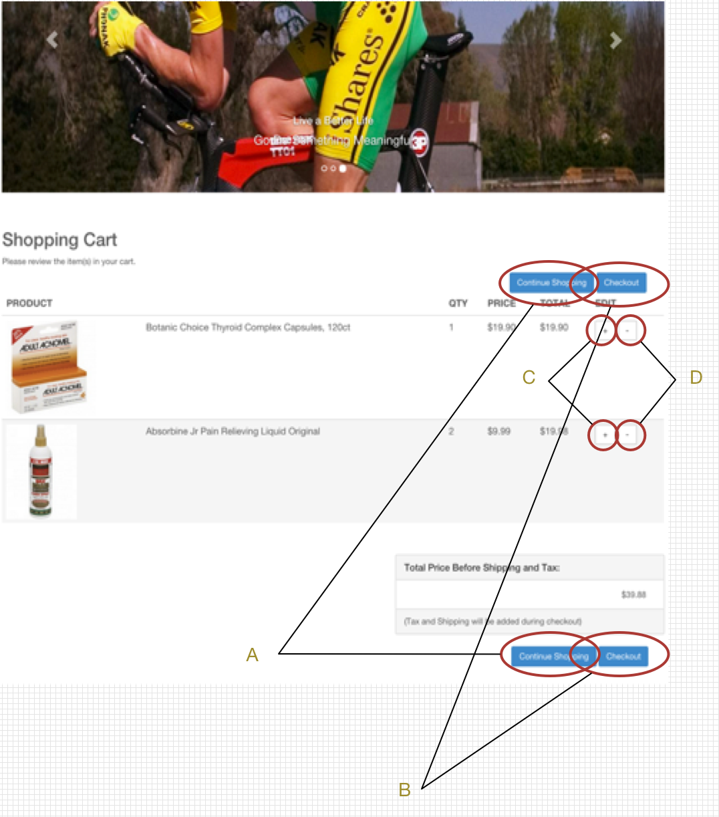2. Action Perform

1. Button “Continue Shopping”: if the user click this button, it will direct the user to the main webpage for user to select any additional item into the cart.
2. Button “Checkout”: if the user click this button, it will direct the user to the checkout webpage for user to complete the checkout process.
3. Button “+”: allow user to increase the quantity of any given item in the cart.
4. Button “-“: allow user to decrease the quantity of any given item in the cart.

**Checkout page:**

We offer three approaches to checkout. At current stage, we eliminate user registration pages and it will jump to next step of checkout.

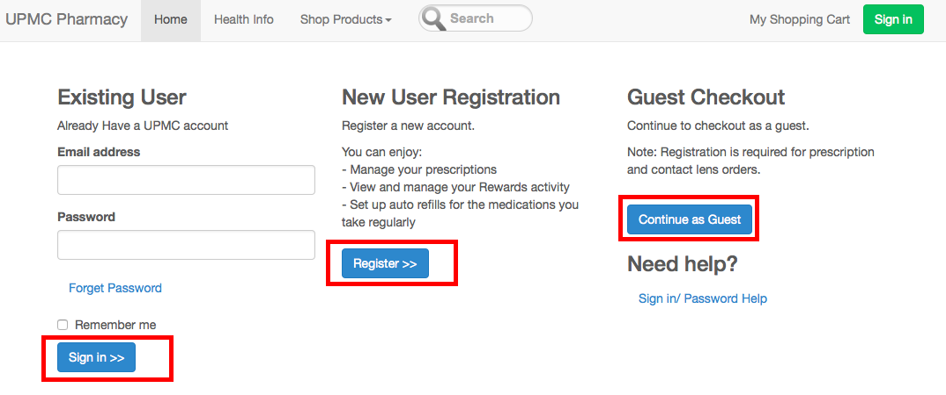

**Shipping information page**

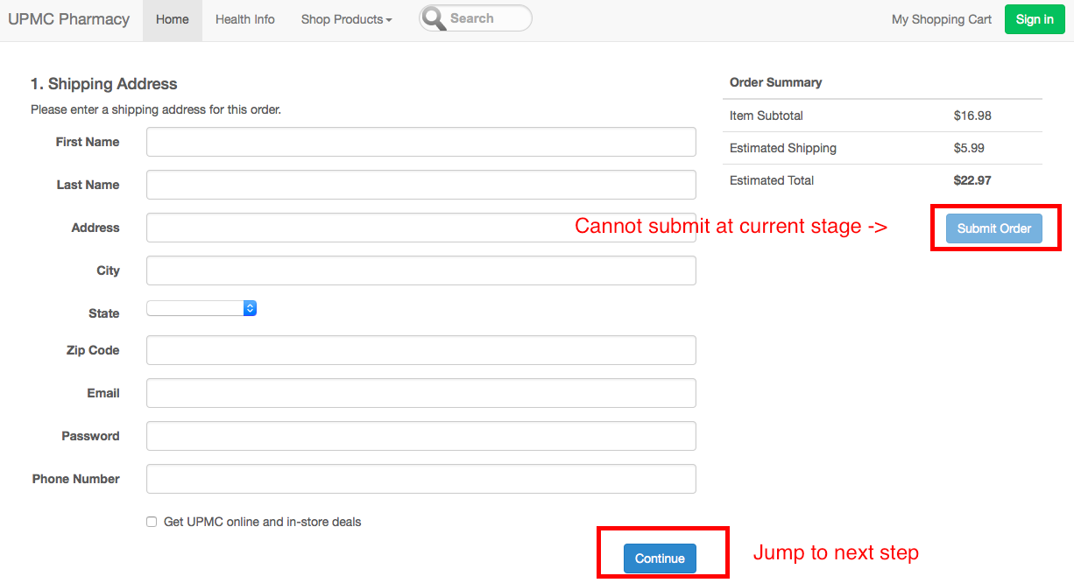

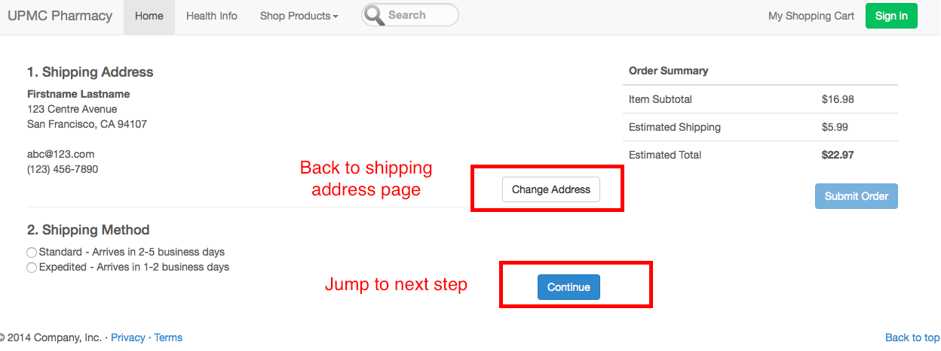

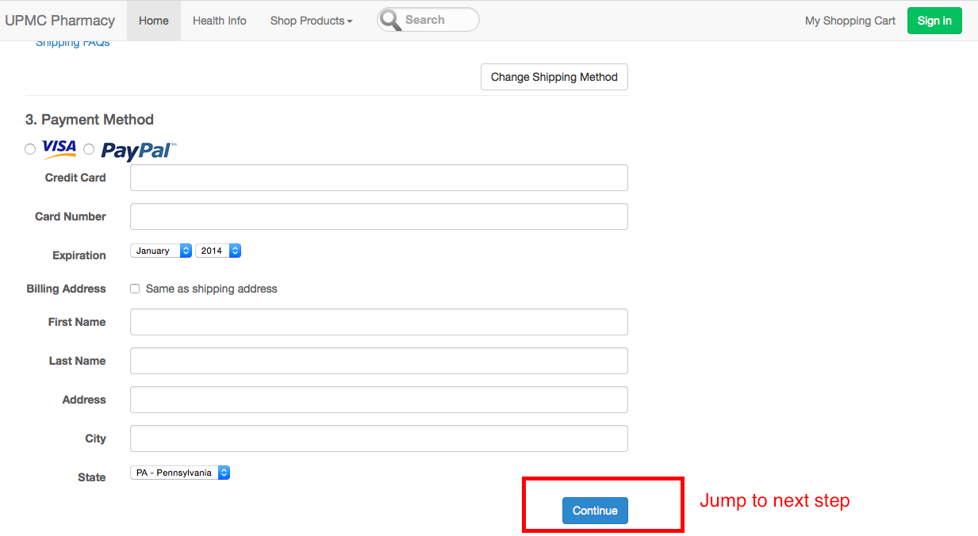

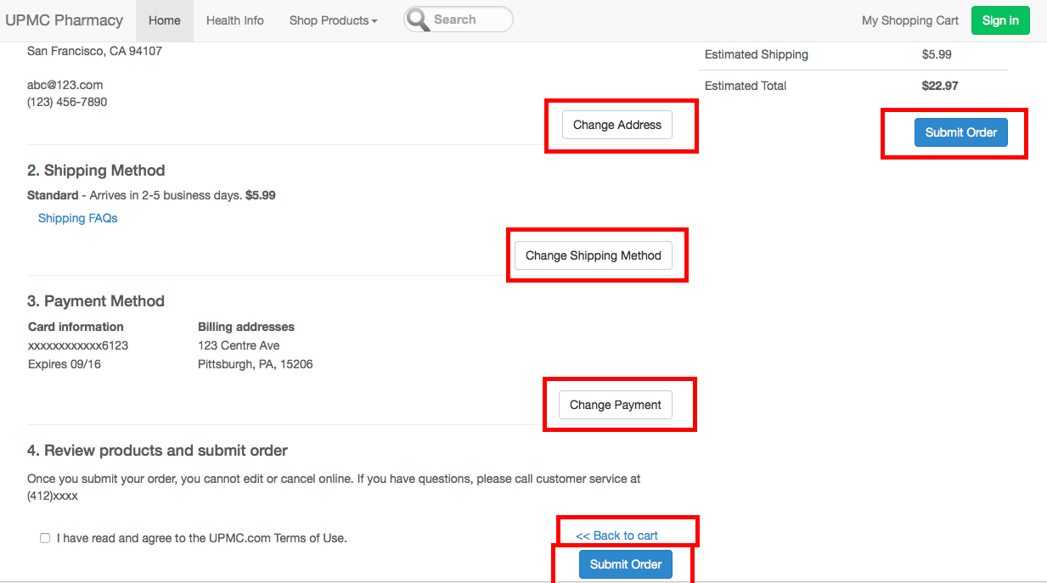

**Order Confirmation:**

It lists out all order information. User can click the bottom button to back to home page

